Phase 5: Project Development & Execution Document
Project Title: Import Data using transform maps (spreadsheets).

1. Development & Execution
This phase covers the technical realization, data ingestion pipeline setup, and execution of automated transform rules within Service Now.

Implementation Overview
Step | Process / Task | Technical Details | Source / Target
01 | Import Set Creation | Ingested source dataset via the Load Data module into the custom staging table. | Source: Excel File (.xlsx)Target: u_employee_import
02 | Transformation Execution | Executed Transform Map "Sample Spreadsheet Import" to process and map attributes into the target table. | Source: u_employee_importTarget: u_employee_test
03 | Coalesce Validation | Re-executed data ingestion with an updated payload to confirm field-matching logic, ensuring duplicate prevention and correct record updates. | Key Field: Coalesce Key (u_emp_id / Email)

Key Execution Highlights
- Import Set Ingestion
  - Loaded source employee data into the staging area using native ServiceNow import set engines.
  - verified data types, encoding, and field mapping structure prior to staging execution.
- Transform Map Configuration & Execution
  - Applied field-level mapping rules via Sample Spreadsheet Import.
  - Handled field transformations, default values, and data normalization during the script pass.
- Validation & Deduplication Logic
  - Validated Coalesce behavior by running delta loads.
  - Confirmed that matching existing records triggers an UPDATE rather than creating duplicate entries in u_employee_test.

2. Reporting & Dashboards
To support operational oversight and post-migration audit readiness, standard reporting views and a centralized executive dashboard were constructed.

Operational Reports
Report Identifier | Report Name | Visualization Type | Purpose / Description
Report 1 | Employees by Department | Pie Chart | Visualizes distribution of active employee records broken down by assigned department.
Report 2 | Employees by Location | Bar Chart | Provides comparative headcount breakdown across global and regional primary office locations.
Report 3 | Employee List Report | Tabular Detail | Detailed record view containing full attribute sets (Name, ID, Department, Manager, Status) for auditing.

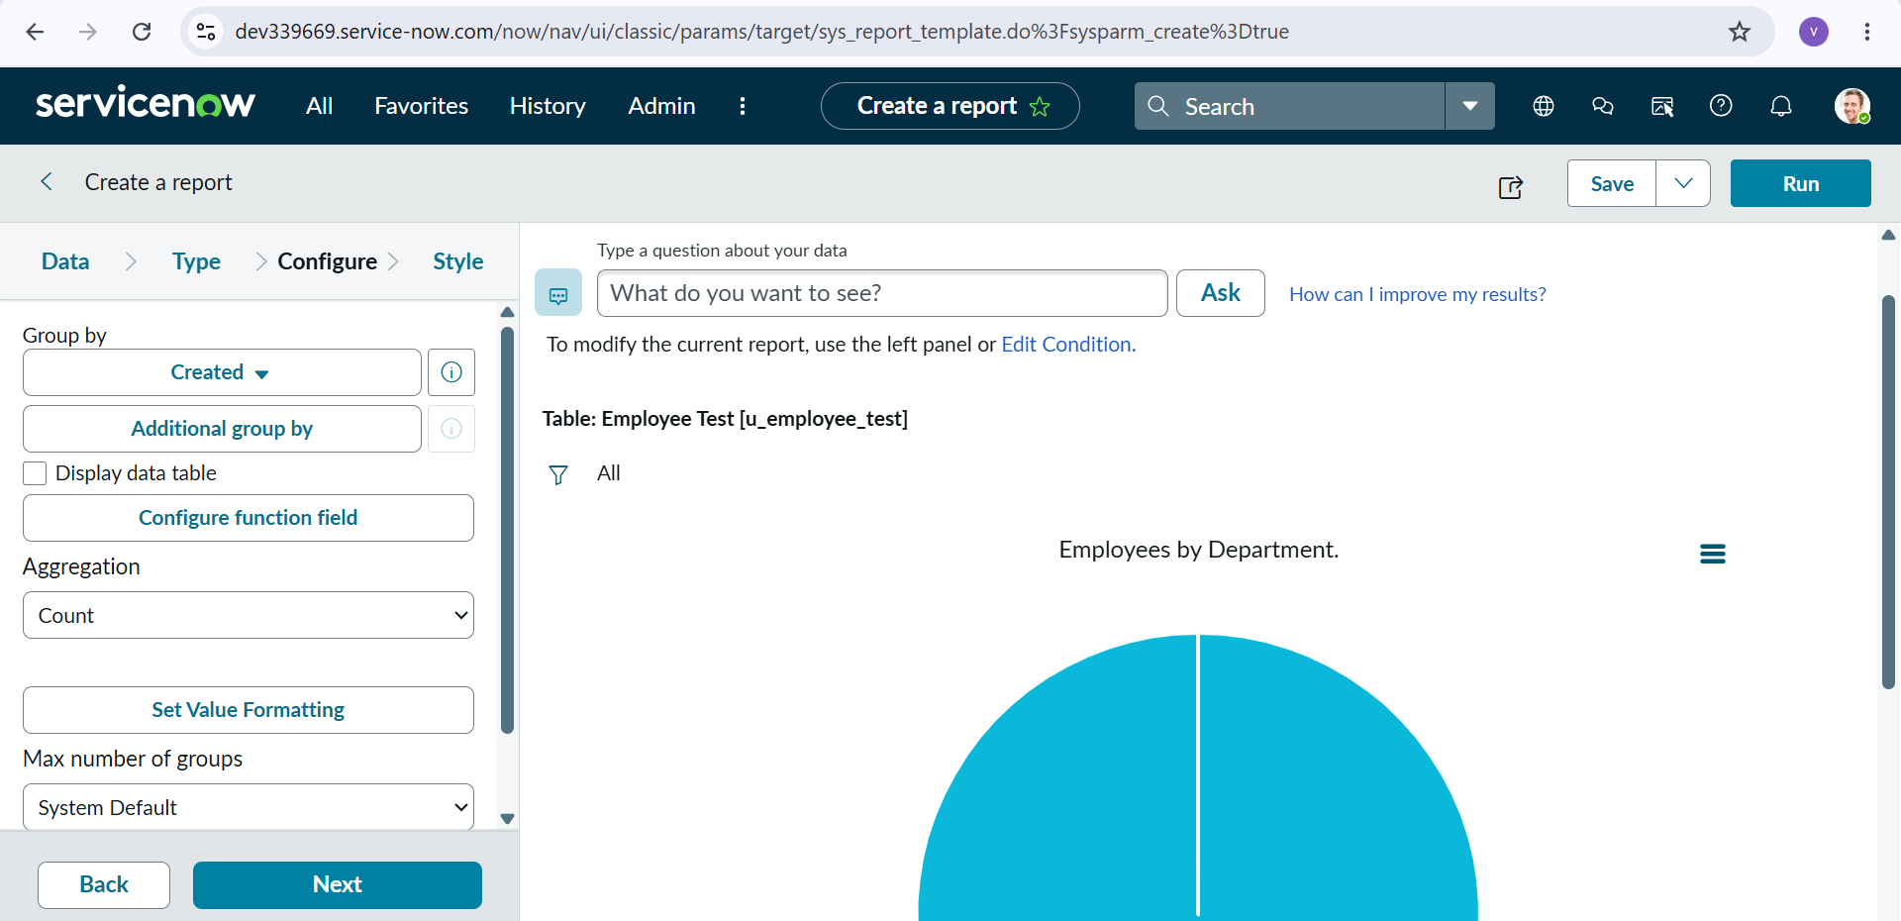

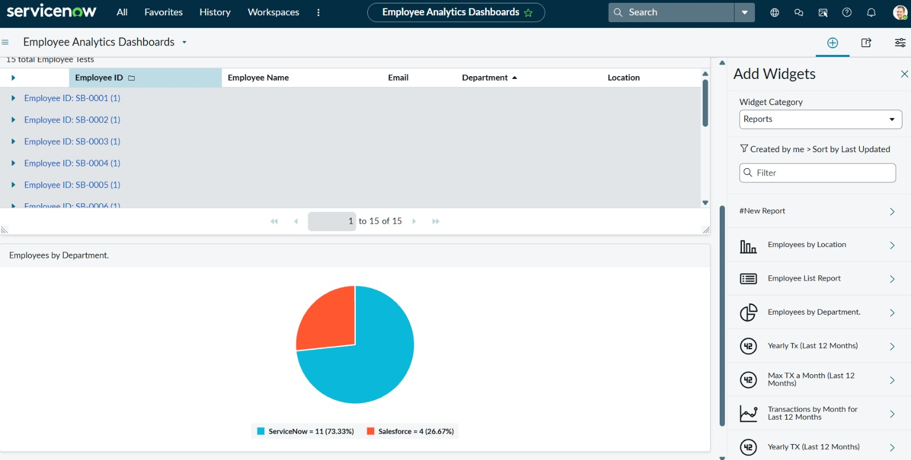

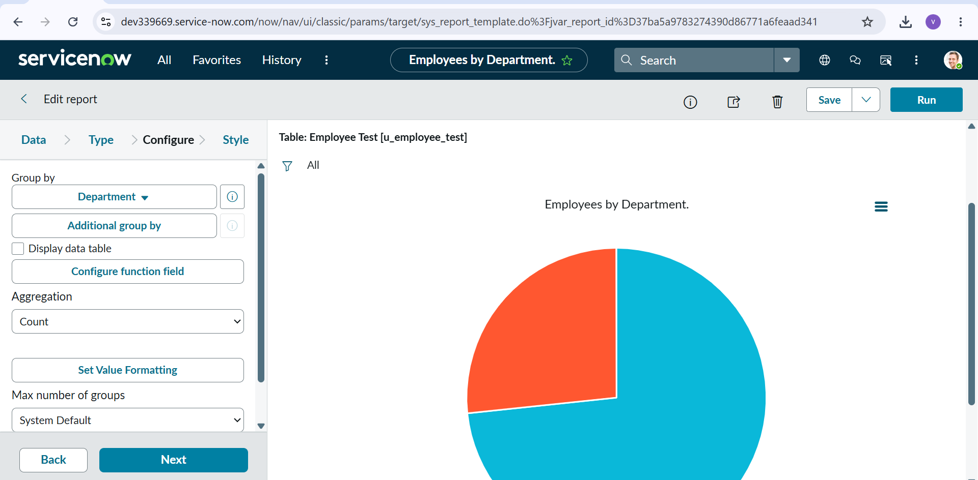

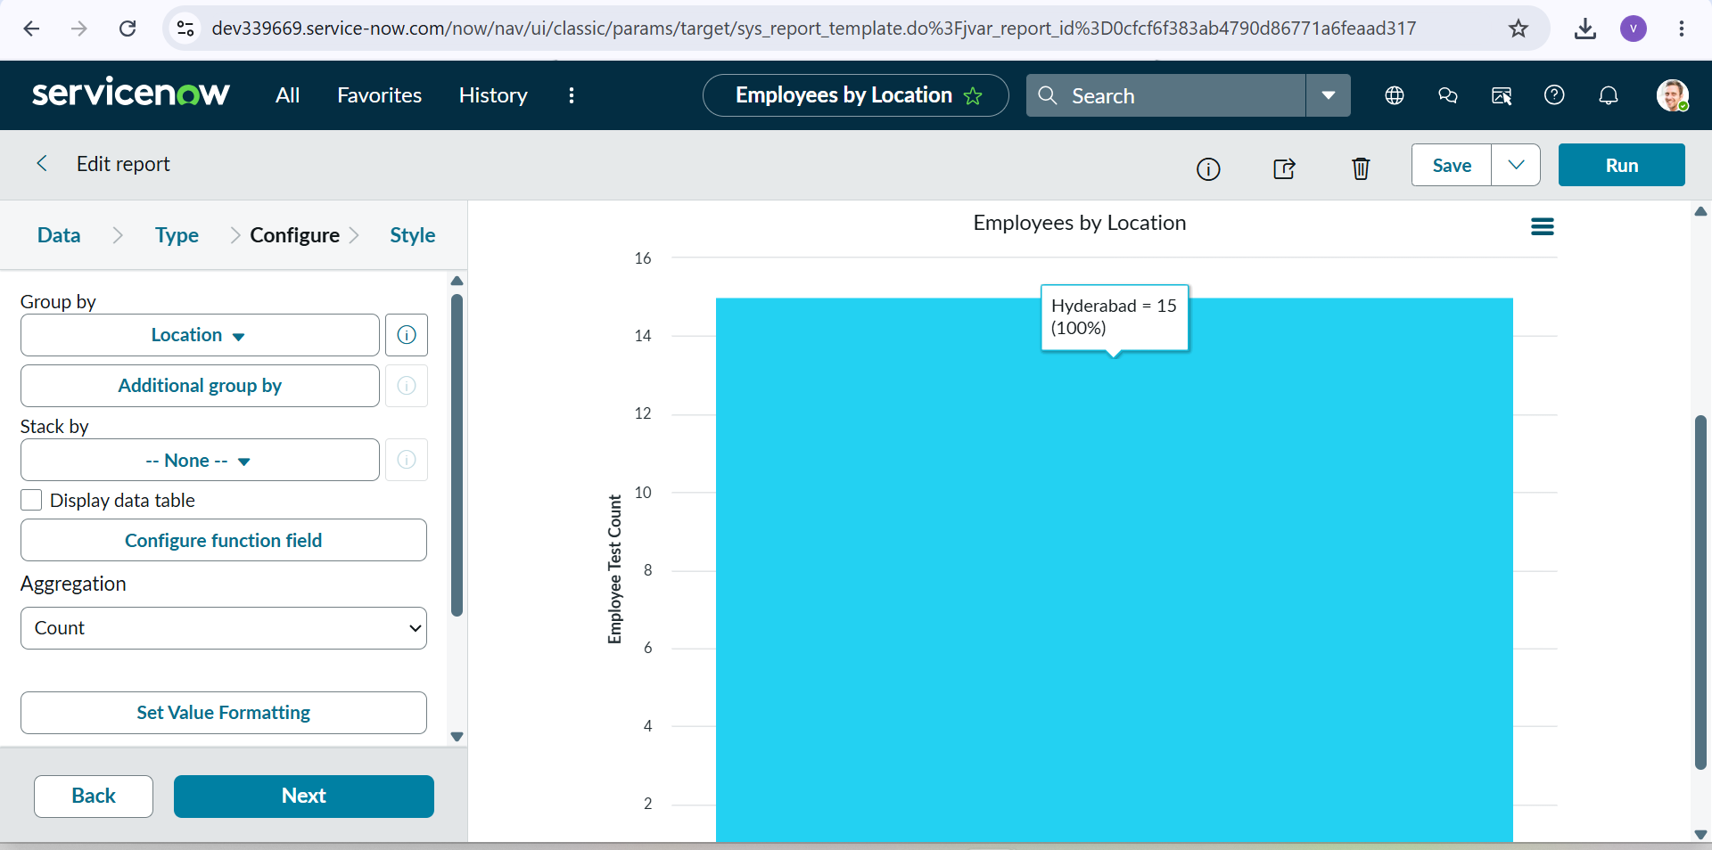

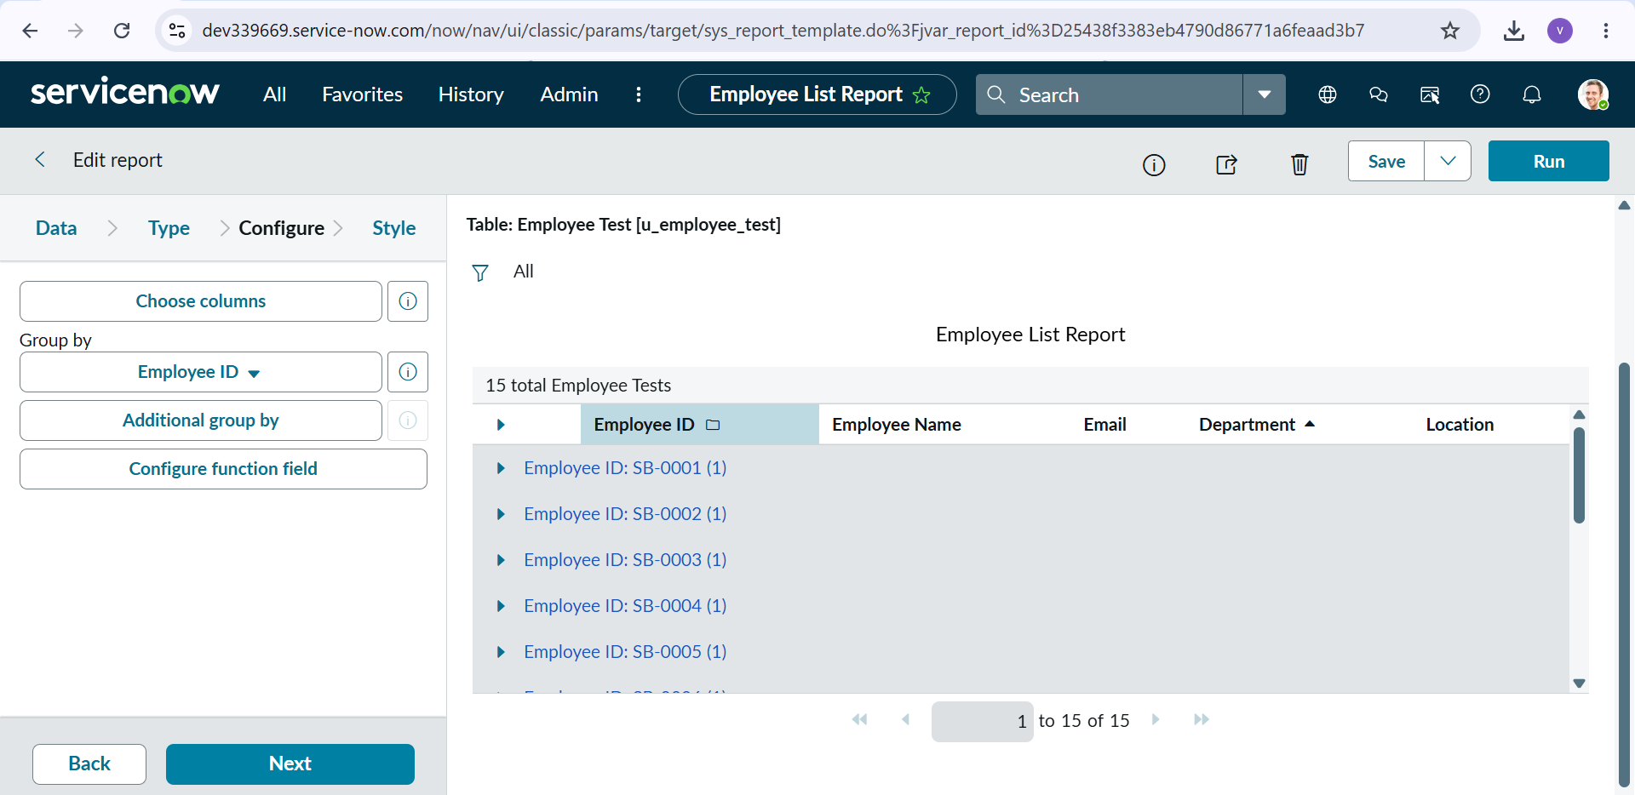

Dashboards & Analytics
- Centralized View: Compiled all core metrics into the Employee Analytics Dashboard.
- Real-time Monitoring: Configured dashboard tiles to dynamically reflect record creation, updates, and demographic shifts directly from u_employee_test.

- 